1)CLASS DIAGRAM

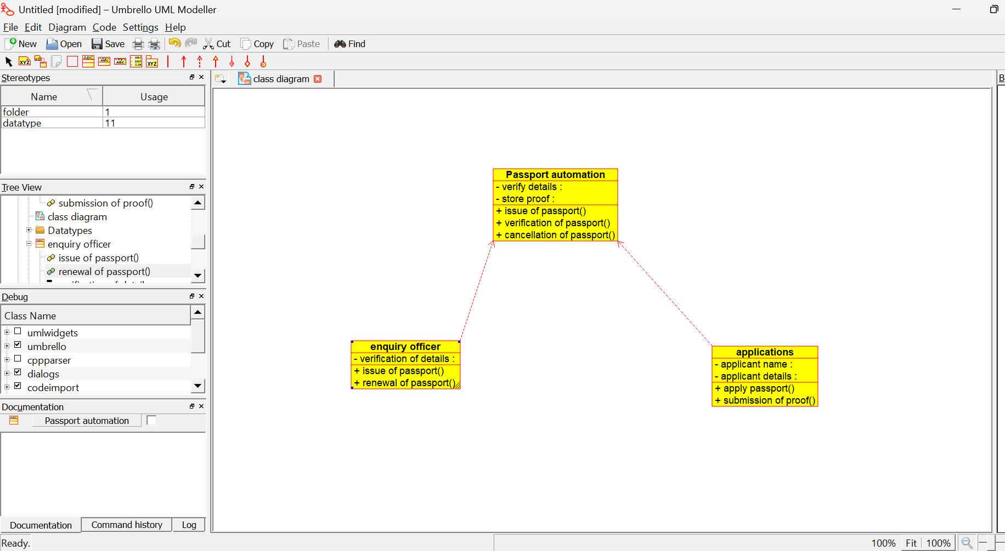

2)COLLABRATION DIAGRAM

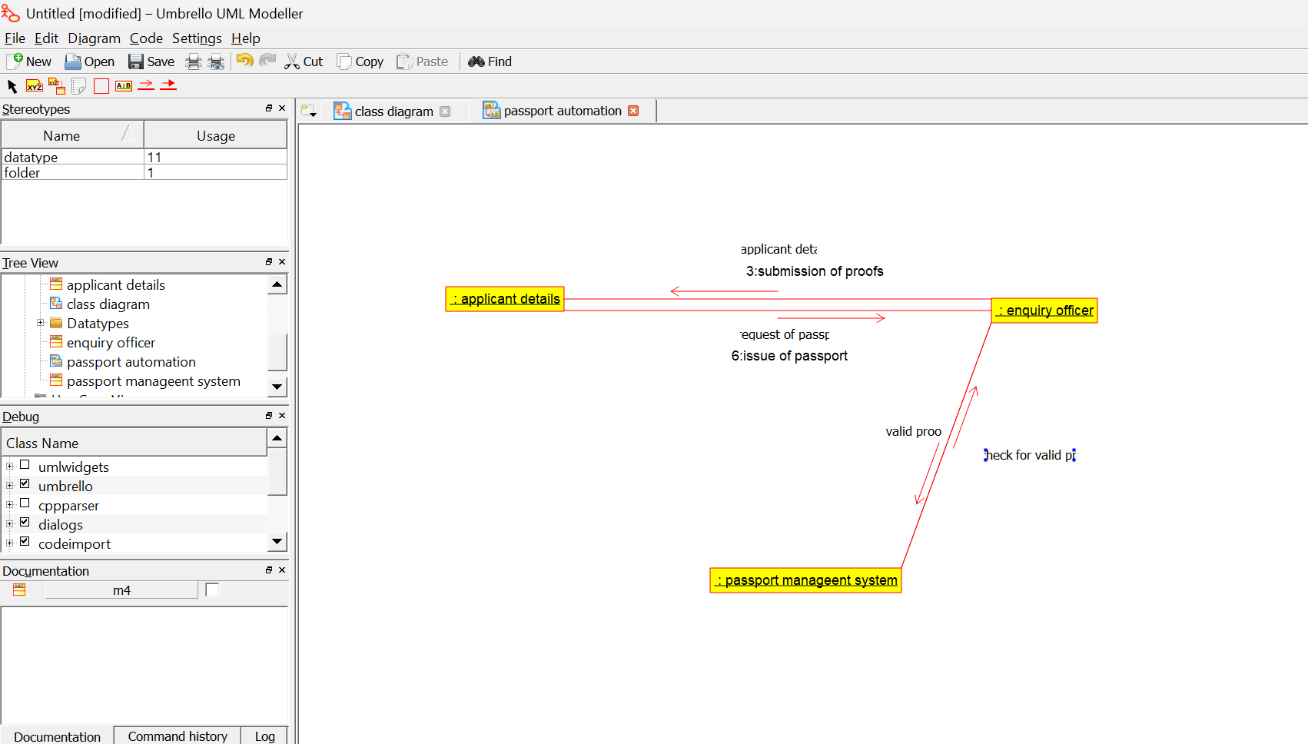

3)COMPONENT DIAGRAM
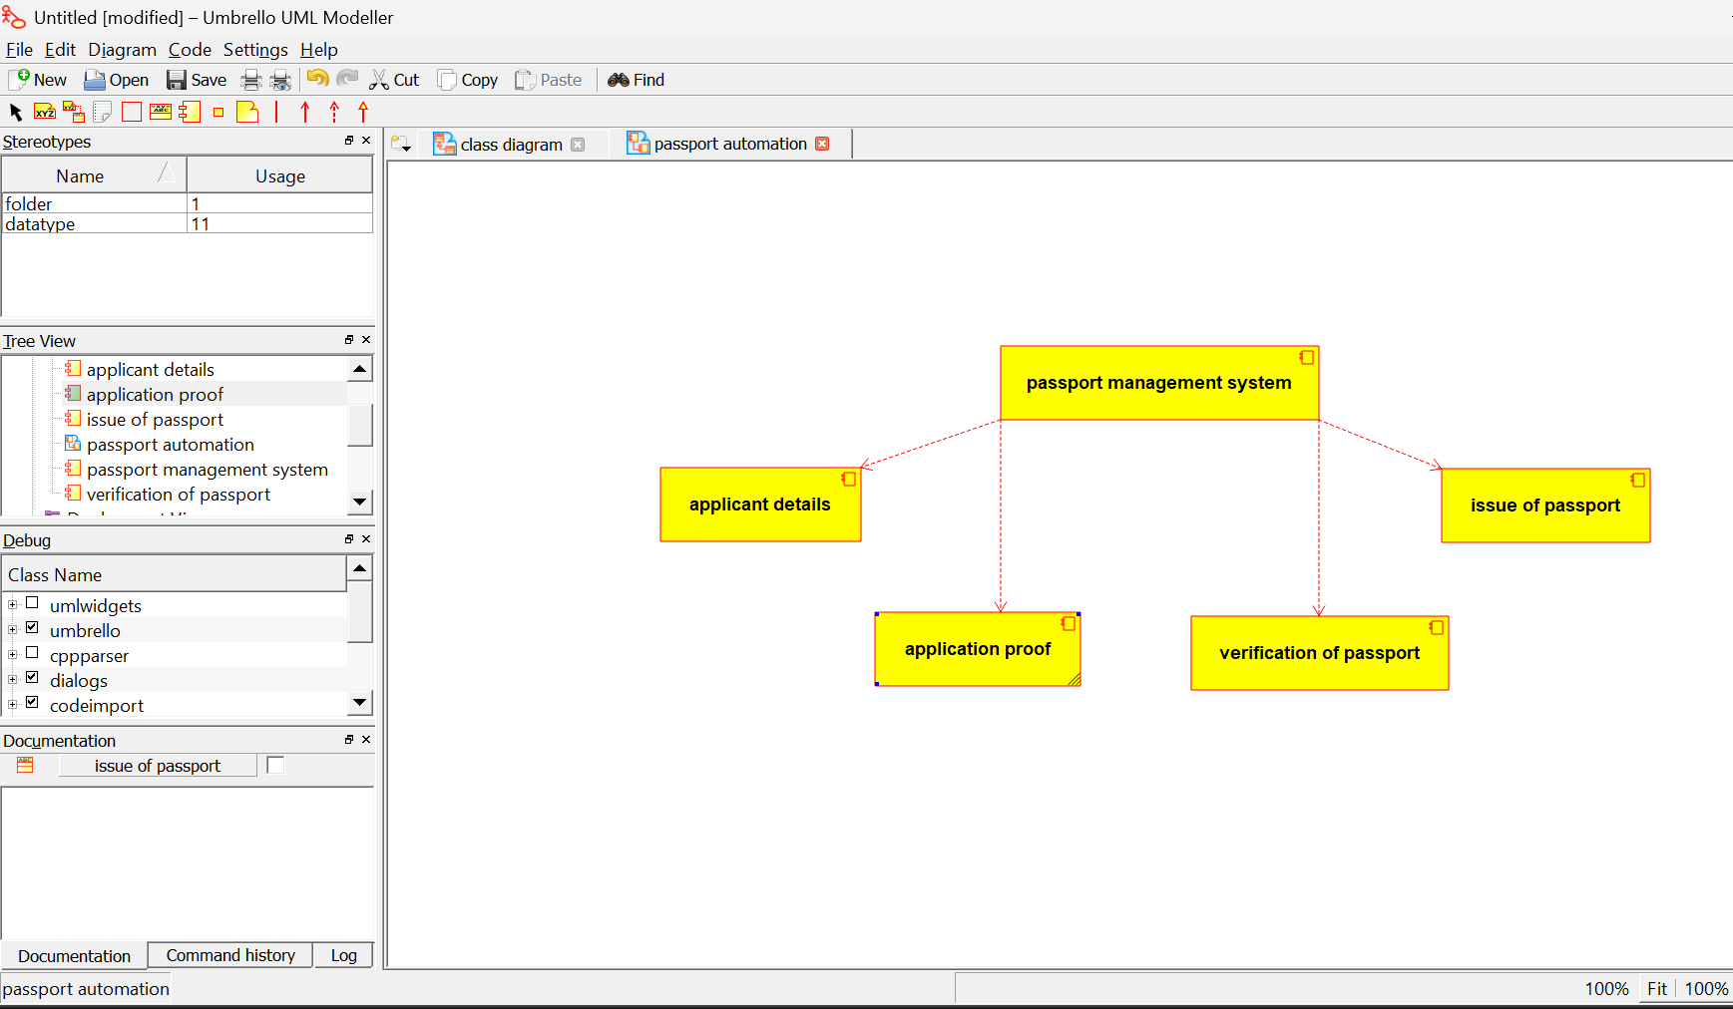

4)DEPLOYMENT

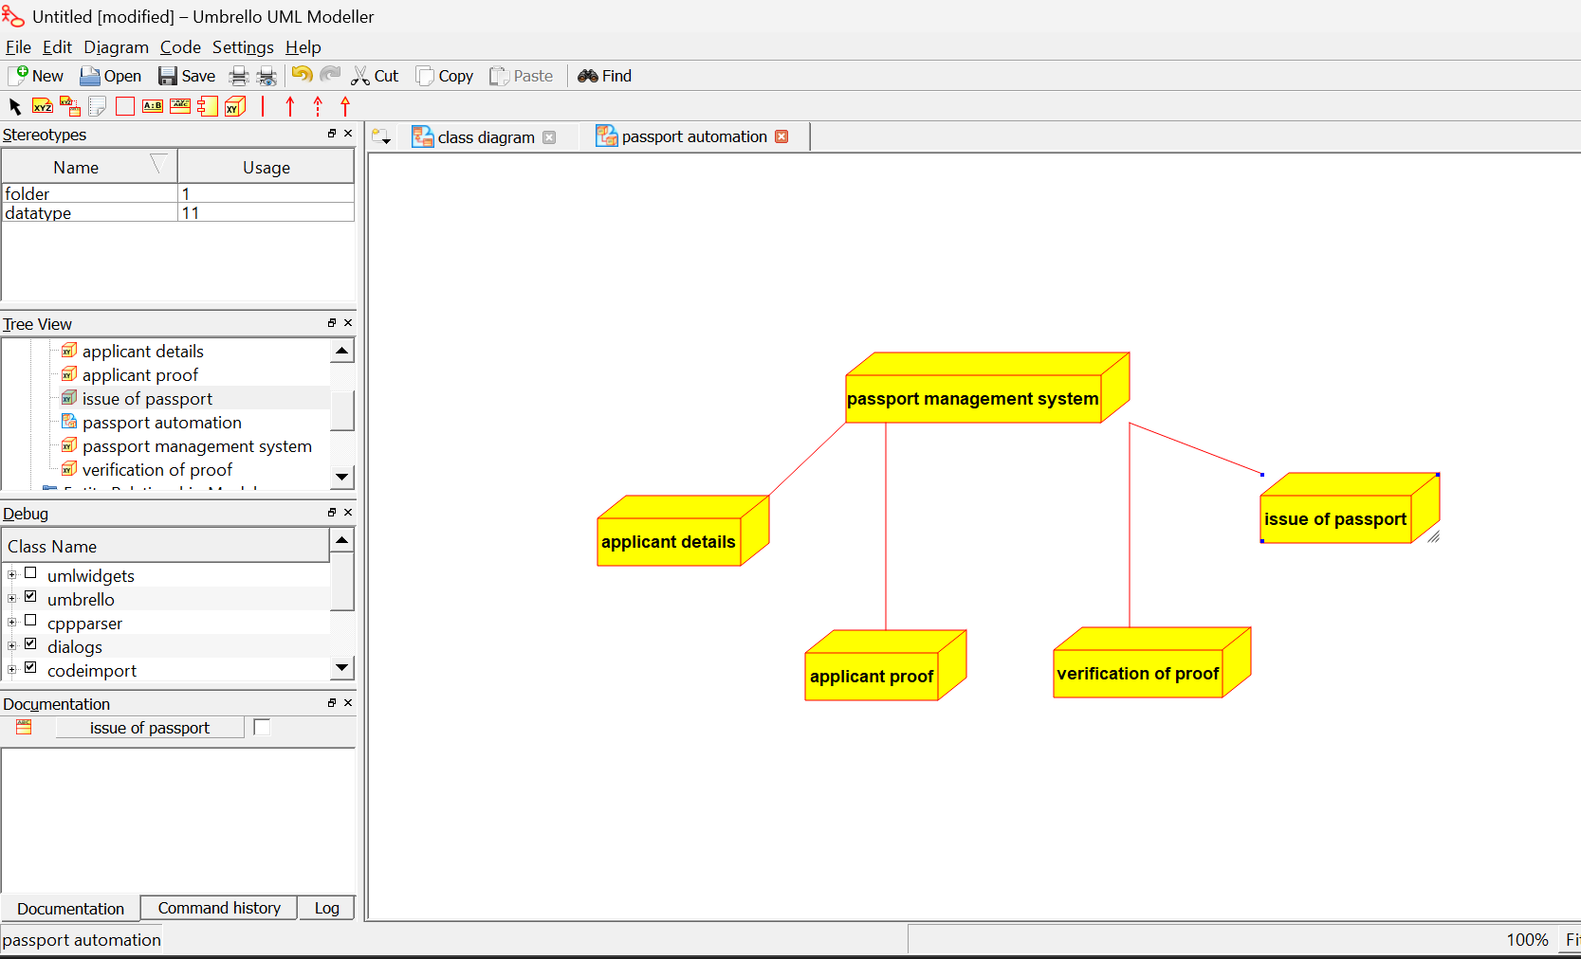

5)PACKAGE DIAGRAM

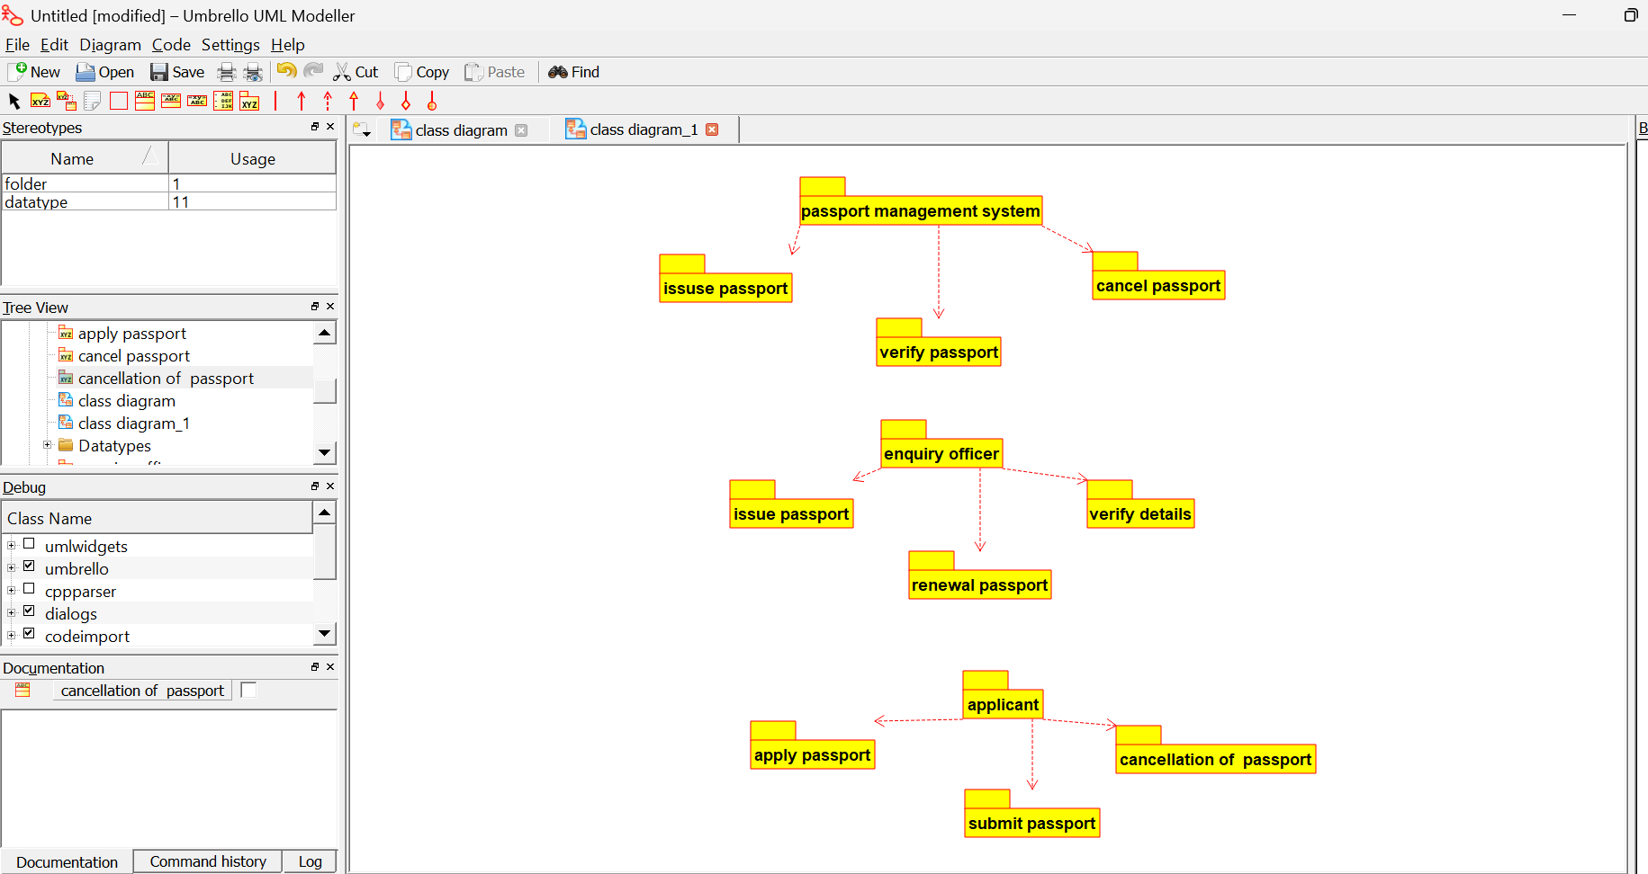

6)SEQUENCE DIAGRAM

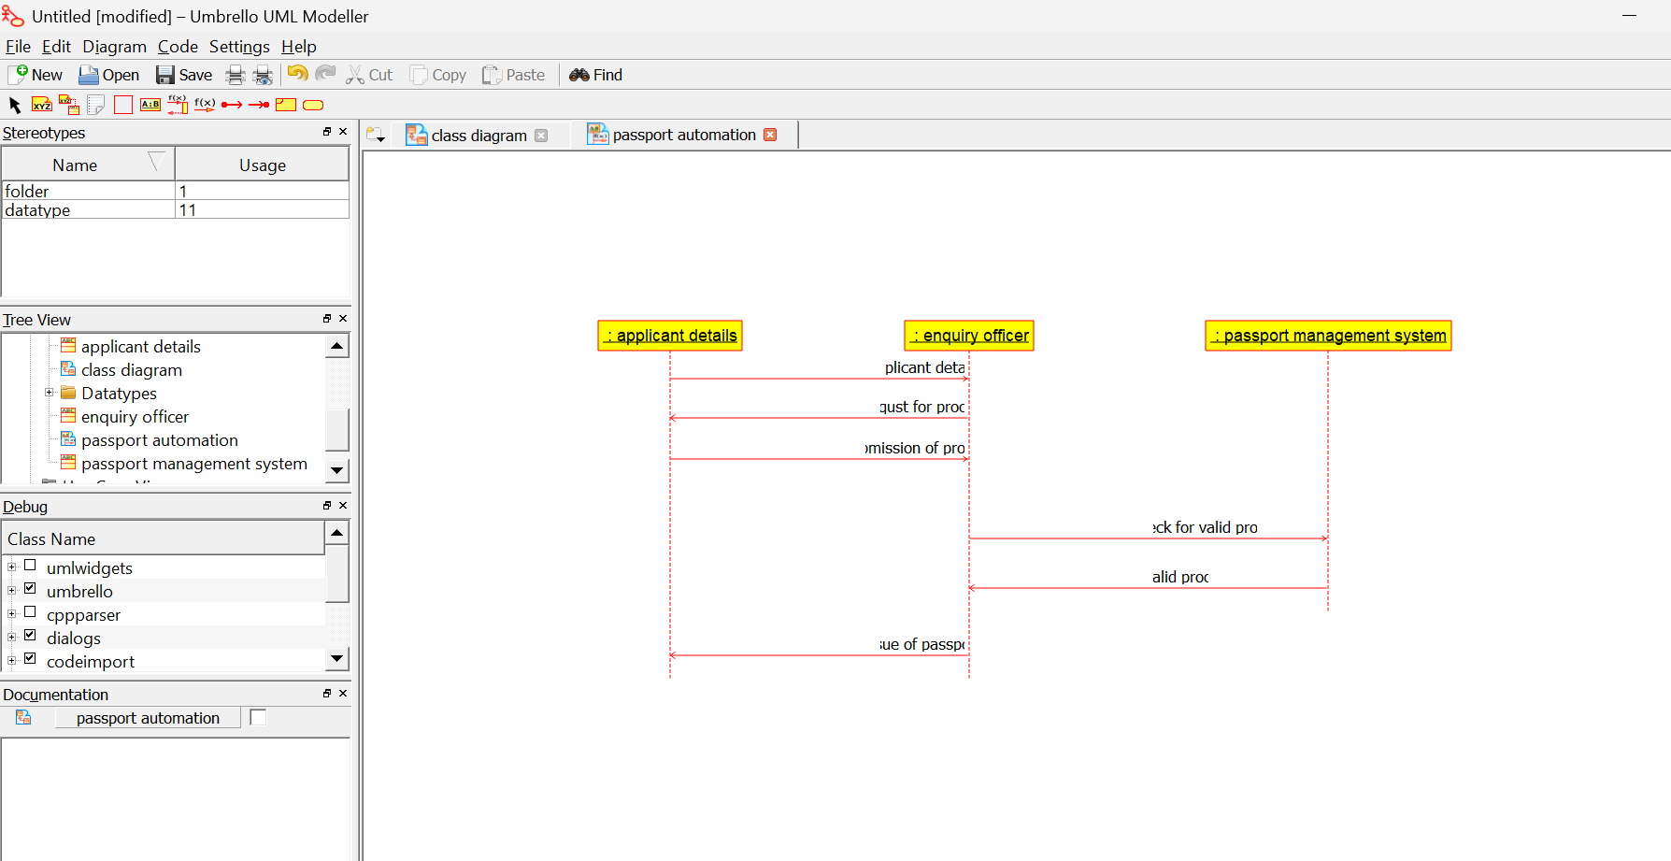

7)STATE DIAGRAM
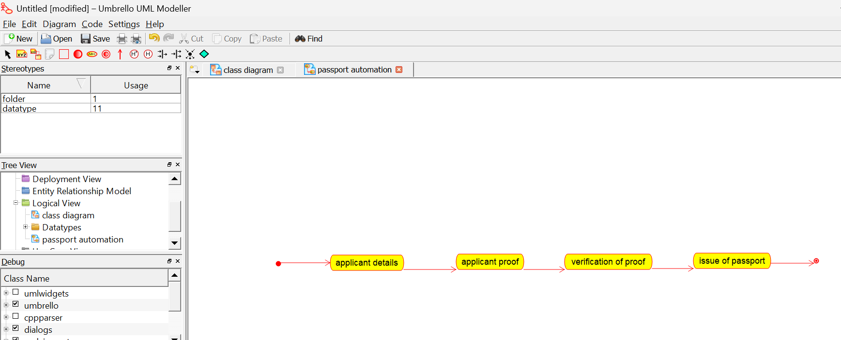

8)USE CASE DIAGRAM
